ASSIGNMENT-2
1. Grade Checker
Take a score as input and print the grade based on the following:
90+ : "A"
80-89 : "B"
70-79 : "C"
60-69 : "D"
Below 60 : "F"
here we used a basic if else statement to carry out marks and all.
ANS 1:
# Grade Checker Program

score = int(input("Enter your score: "))

if score >= 90:
print("Grade: A")
elif score >= 80:
print("Grade: B")
elif score >= 70:
print("Grade: C")
elif score >= 60:
print("Grade: D")
else:
print("Grade: F")
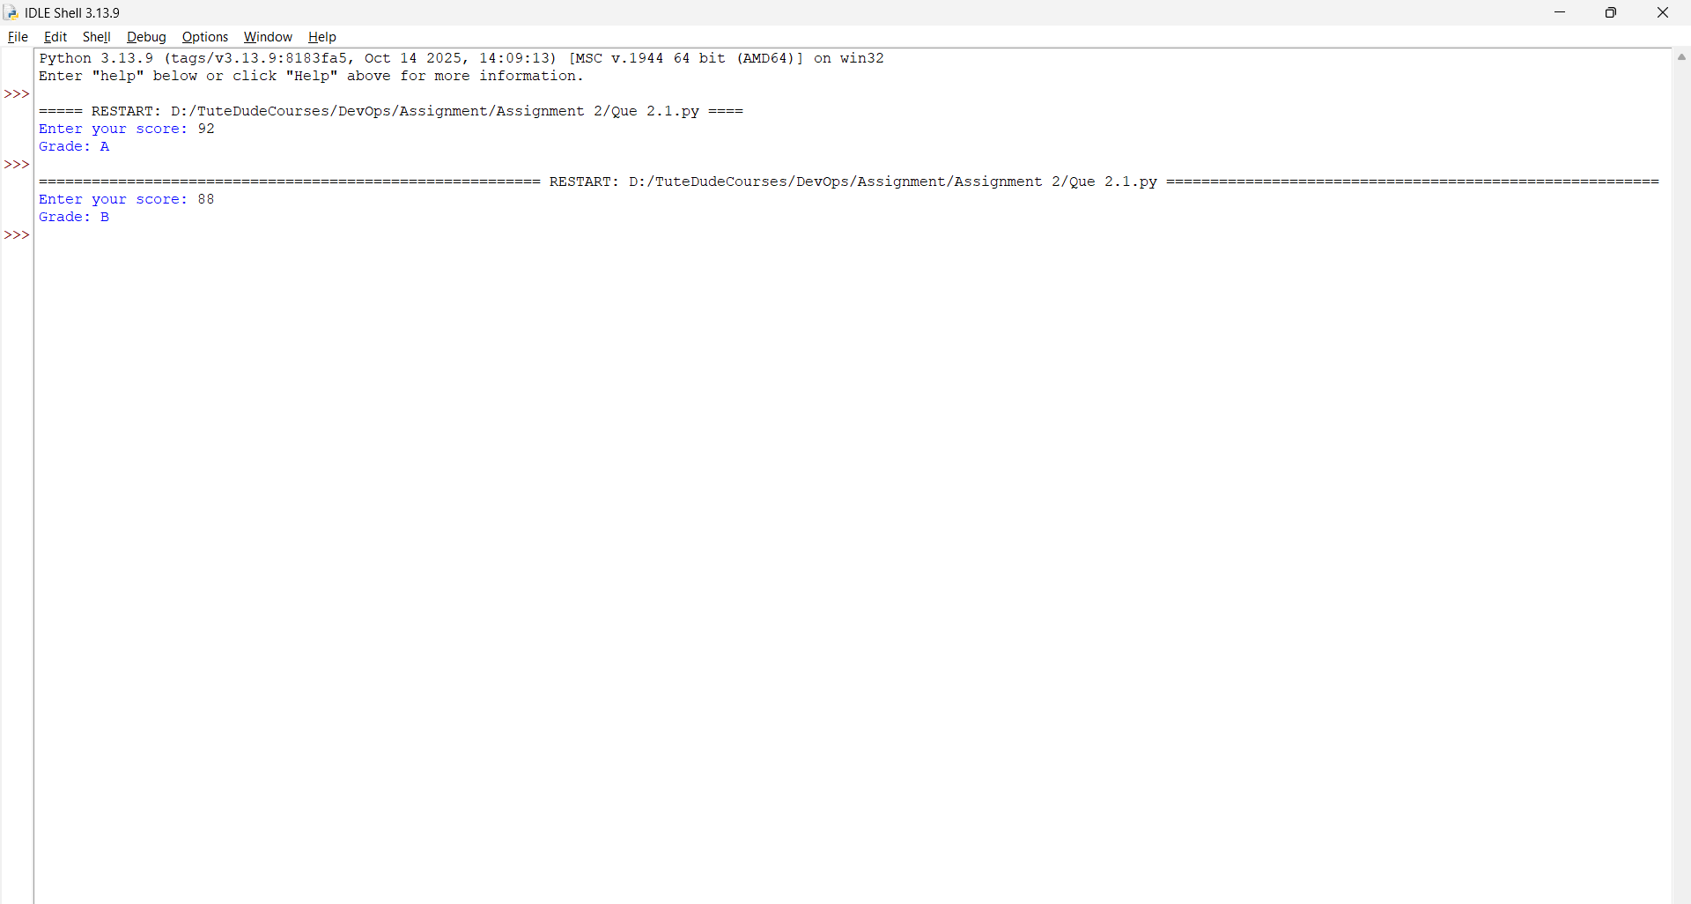
2 Student Grades
Create a dictionary where the keys are student names and the values are their grades. Allow the user to:
Add a new student and grade.
Update an existing student’s grade.
Print all student grades.

Used dictionary and basic operations. Using if else:
ANS 2:
# Student Grades Program
students = {}
while True:
print("\n1. Add Student")
print("2. Update Student Grade")
print("3. Print All Student Grades")
print("4. Exit")

choice = input("Enter your choice (1-4): ")

if choice == "1":
name = input("Enter student name: ")
grade = input("Enter student grade: ")
students[name] = grade
print("Student added successfully!")
elif choice == "2":
name = input("Enter student name to update: ")
if name in students:
grade = input("Enter new grade: ")
students[name] = grade
print("Grade updated successfully!")
else:
print("Student not found!")
elif choice == "3":
if students:
print("\nStudent Grades:")
for name, grade in students.items():
print(name, ":", grade)
else:
print("No students in the record.")
elif choice == "4":
print("Exiting program...")
break
else:
print("Invalid choice! Please select 1-4.")
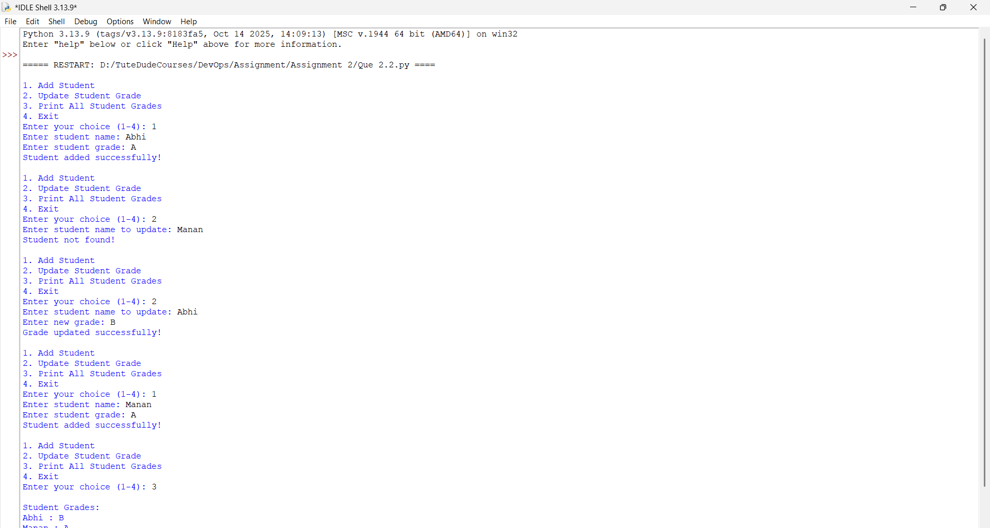
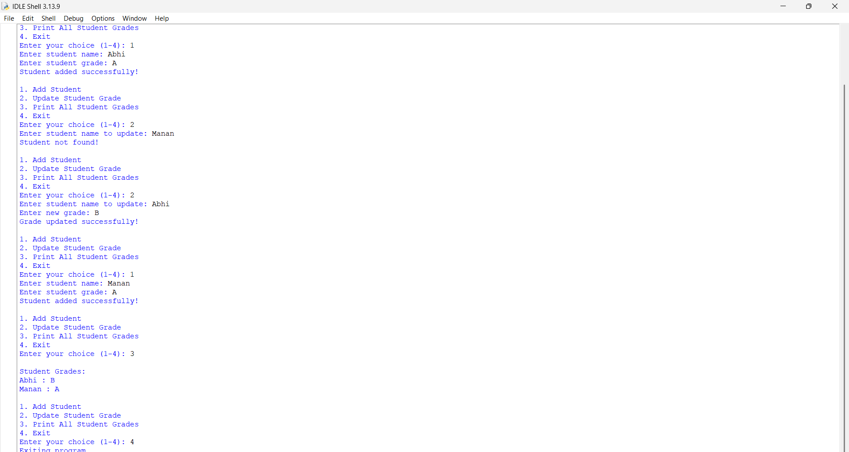
3.Write to a File
Write a program to create a text file and write some content to it.

Using file functions like write and open.
ANS 3:
# Write to a File Program

file = open("sample.txt", "w") # "w" mode creates the file (or overwrites if it exists)

file.write("Hello, this is a sample text file.\n")
file.write("This file was created using Python.\n")
file.write("We are learning file handling.\n")

file.close() # Always close the file

print("Content written successfully to sample.txt")
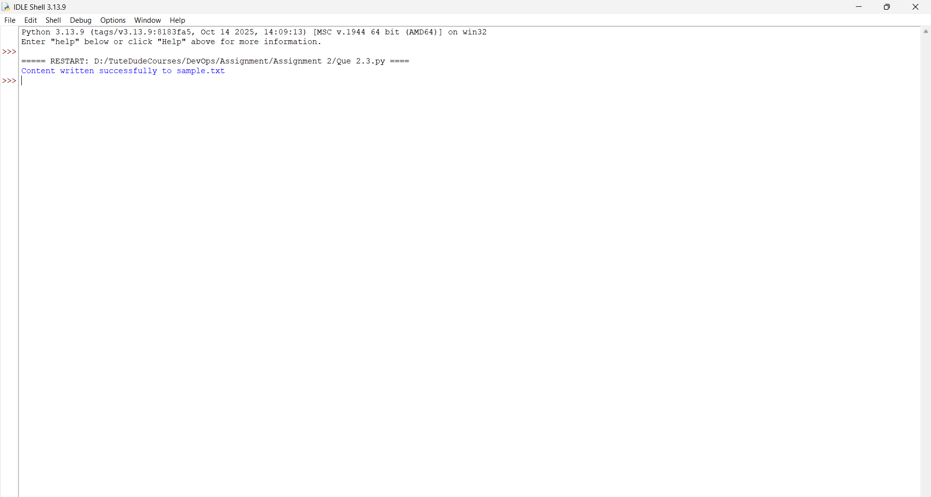
4. Read from a File
We used open in read mode and file.read to read and print to display.
ANS 4:
# Read from a File Program

# Open the file in read mode
file = open("sample.txt", "r") # "r" mode is for reading

# Read the entire content
content = file.read()

# Print the content
print("File Content:\n")
print(content)

# Close the file
file.close()
